**Information System Management Lab**

**BCOM 307**

**Assignment #25**

***Submitted by:***

**Name:** YASH JAIN

**Enrollment No:** 03914788818

**Semester:** B.Com(H) 5TH Semester

**Class:** B.COM(H)

**Section:** B.Com 5A

**Date of Submission:** 15/11/2021

***Submitted to:***

**Praveen Kumar Singh**

**Assistant Professor, MAIMS**



**Department of Commerce**

**Maharaja Agrasen Institute of Management Studies**

**Affiliated to Guru Gobind Singh Indraprastha University, Delhi**

**Sector -22, Rohini, Delhi -110086, India; www.maims.ac.in**

Maharaja Agrasen Institute of Management Studies

Affiliated to GGS IP University; Recognized u/s 2(f) of UGC Recognized by Bar Council of India; ISO 9001: 2015

Certified Institution Sector 22, Rohini, Delhi -110086, India; [www.maims.ac.in](http://www.maims.ac.in/)

Department of Commerce

Academic Year: 2020-21

Semester: Vth

# Assignment No. 25

# Unit No:

**Course/Subject Code:** BCOM 307 **Subject Title: Information System Management Lab**

# Issue Date Last Date of Submission:

**Instructions for Students:**

# All Questions are Compulsory.

1. The student should attach proper cover page for each assignment clearly mentioning the Assignment No.
2. Each assignment should be prepared by the student individually with proper explaination and screenshots.
3. A4 size ruled sheets should be used for the assignment.
4. Assignment pages should be serially numbered at the bottom of page.

***During online education mode, upload scanned copy of the complete assignment including cover page latest by due date.***

|  |  |  |
| --- | --- | --- |
| **Question No.** | **Question** | **CO No.** |
| 1 | Display first 3 characters from the employee name column of the employees table. | **CO2, CO3, CO4, CO5** |
| 2 | Display all the distinct values of the column 'location'. |
| 3 | Display the values of employee name column after removing spaces from the right. |
| 4 | Display the values of employee name column after removing spaces from the left. |
| 5 | Display the values of employee name column after replacing the letter 'A' with 'a'. |
| 6 | Display all columns of the employee table in ascending order of employee names. |
| 7 | Display all columns of the employee table in ascending order of employee names and descending order of department number. |
| 8 | Show all employee names except Elon Musk and Ratan Tata. | **CO2, CO3, CO4, CO5** |
| 9 | Display the values where employee name ends with 'a'. |
| 10 | Display the employee records of employees hired in April 2013. |

**ASSIGNMENT 25 - STRING FUNCTIONS**

**Task 1 : Display first 3 characters from the employee name column of the employees table.**

This task can be completed using the SQL String Function **SUBSTRING( ).** This function extracts some characters from a string, specified as one of its parameters, as follows :

Select SUBSTRING (string, start, length) from <tablename>;

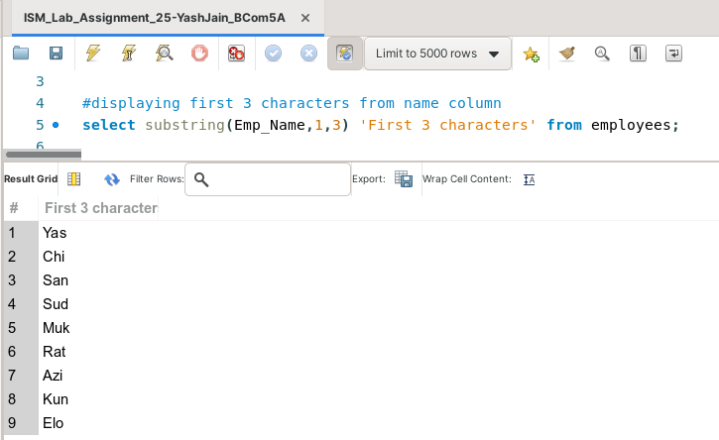

**Task 2: Display all the distinct values of the column 'location'.**

This task can be completed using the **DISTINCT** Keyword.

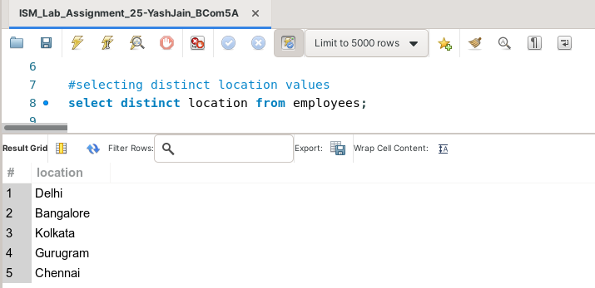

**Task 3: Display the values of employee name column after removing spaces from the right.**

This task can be completed using the **RTRIM( )** Aggregate function. This function returns a string after eliminating trailing spaces from the string. We have to specify the string as its arguments as follows :

Select RTRIM (string)from <tablename> ;

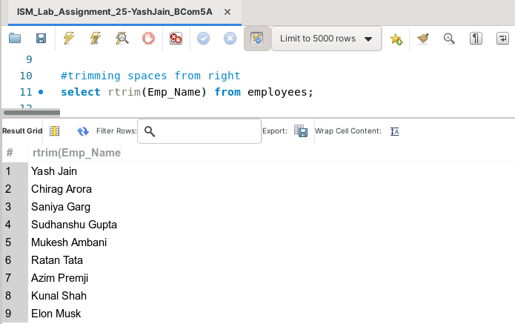

**Task 4: Display the values of employee name column after removing spaces from the left.**

This task can be completed using the **LTRIM( )** Aggregate function. This function returns a string after eliminating leading spaces from the string. We have to specify the string as its arguments as follows :

Select LTRIM (string)from <tablename> ;

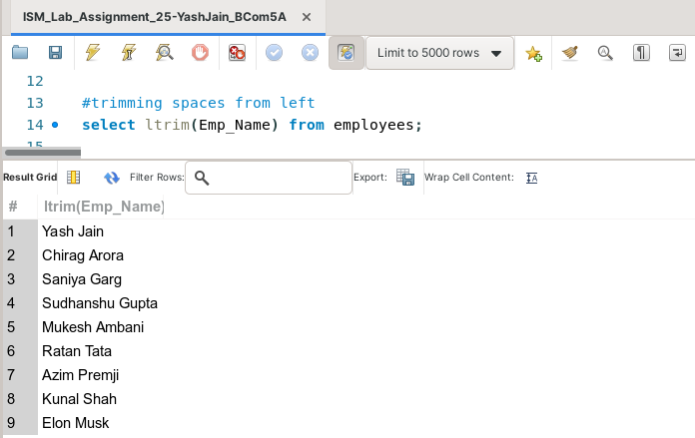

**Task 5: Display the values of employee name column after replacing the letter 'A' with 'a'.**

This task can be completed using the **REPLACE( )** Aggregate function. This function returns a string after replacing a character in the string with the one we specify in its arguments as follows ::

Select REPLACE (STRING,Old character,new character) from <table>;

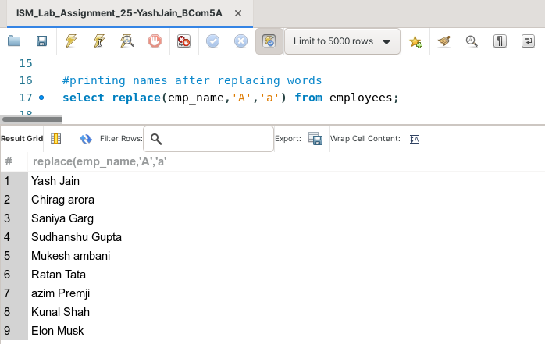

**Task 6: Display all columns of the employee table in ascending order of employee names.**

This task can be completed using the **ORDER BY** Clause**.**

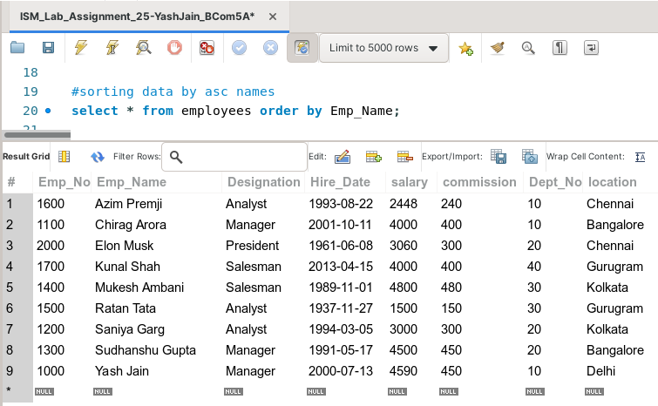

**Task 7: Display all columns of the employee table in ascending order of employee names and descending order of department number.**

This task can be completed using the **ORDER BY** clause.

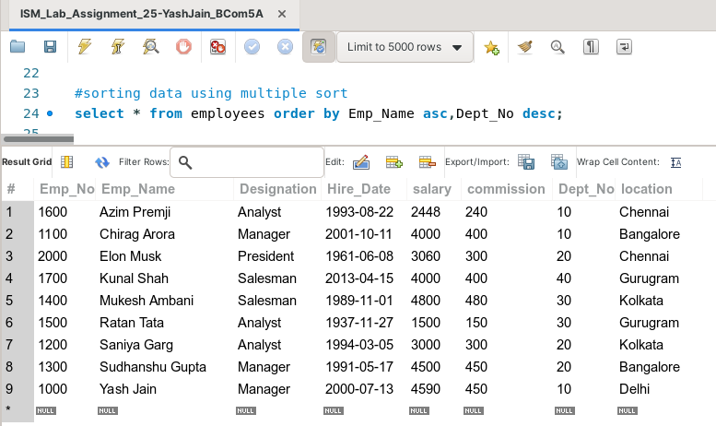

**Task 8: Show all employee names except Elon Musk and Ratan Tata.**

This task can be completed using the **NOT IN** clause.

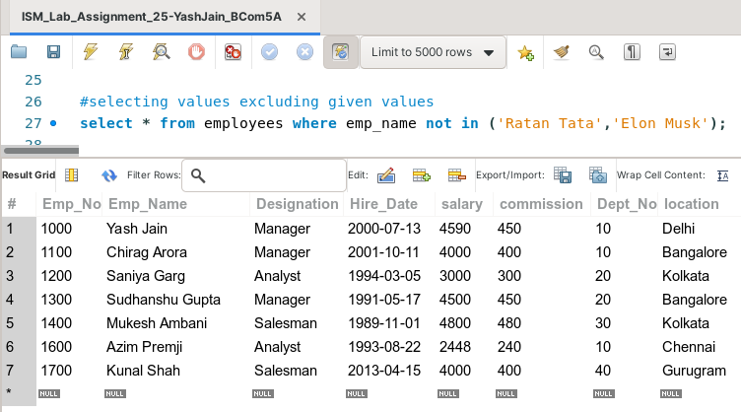

**Task 9: Display the values where employee name ends with 'a'.**

This task can be completed using the **LIKE** predicate, along with the % (percentage) symbol**.**

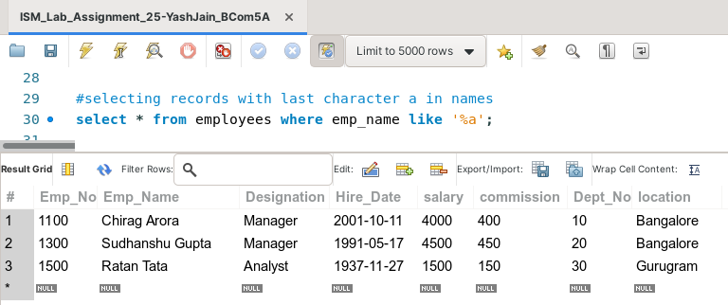

**Task 10: Display the employee records of employees hired in April 2013.**

This task can be completed using the **BETWEEN** and **WHERE** Clauses.

